# File Handling

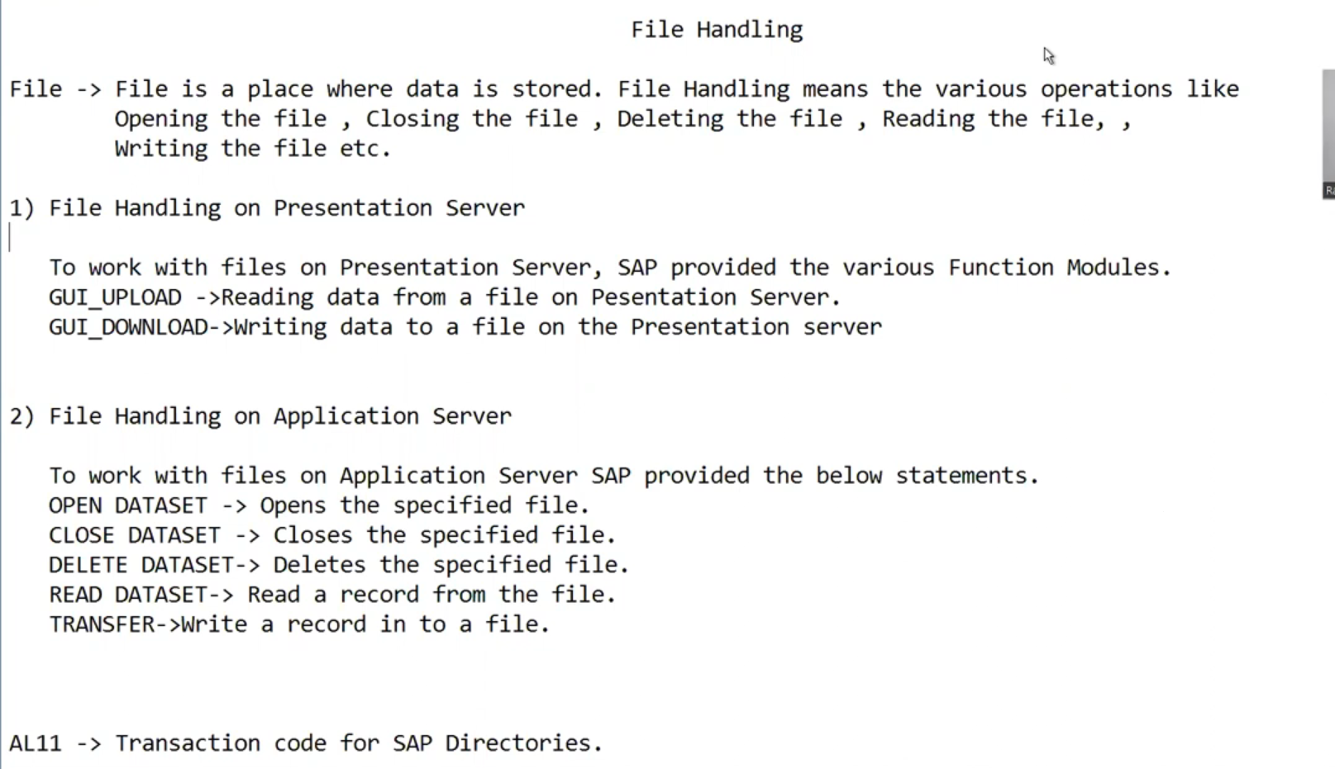

Figure 1 File Handling.

## File Handling on Presentation Server.

A file on your local workstation or local PC which means it is on the presentation layer.

### Function Module used.

#### GUI_UPLOAD

Reading data from a file on the presentation server.

#### GUI_DOWNLOAD

Writing data to a file on the presentation server.

### Step-by-step implementation

We will read the data from the file from the application server.

#### Prepare data.

We will create data in Excel because by default it is separated by space.

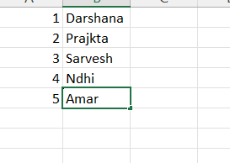

Figure 2 Add the data in Excel.

Copy the data and add it to the notepad it will be separated by space so there where will be no confusion while reading the data.



Figure 3 Separated by tab.

Save it on the desktop.

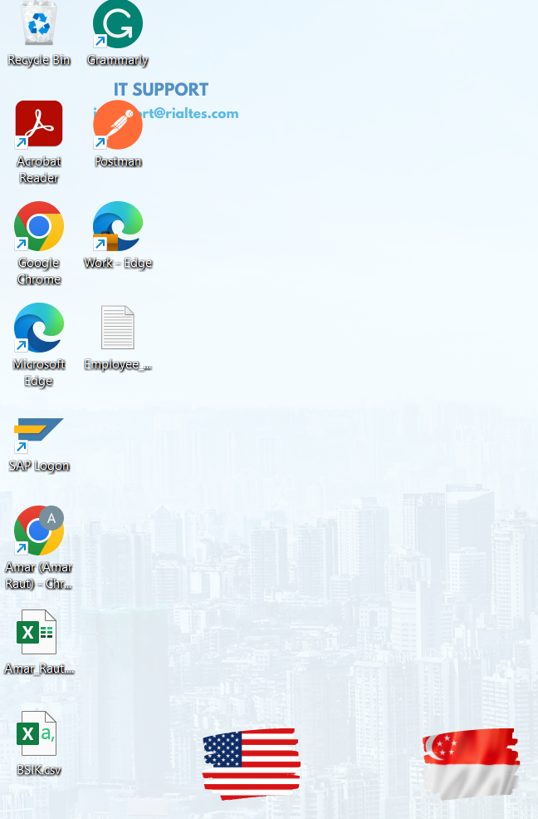

Figure 4 File is present on the desktop.

Now we will create the program to read the file from the presentation layer.

#### Navigate to SE38

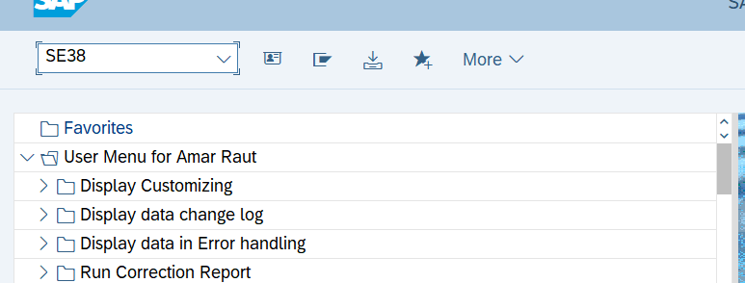

Figure 5 Navigate to SE38.

#### Create a program to Upload the data or read the data.

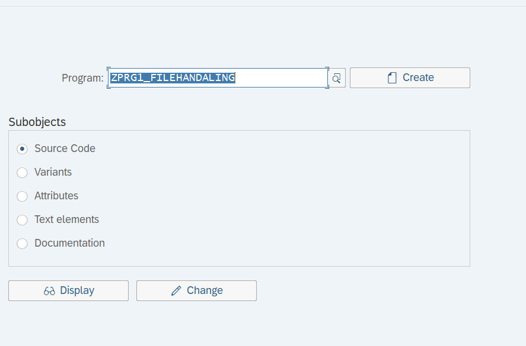

Figure 6 Creating a program for the file handling.

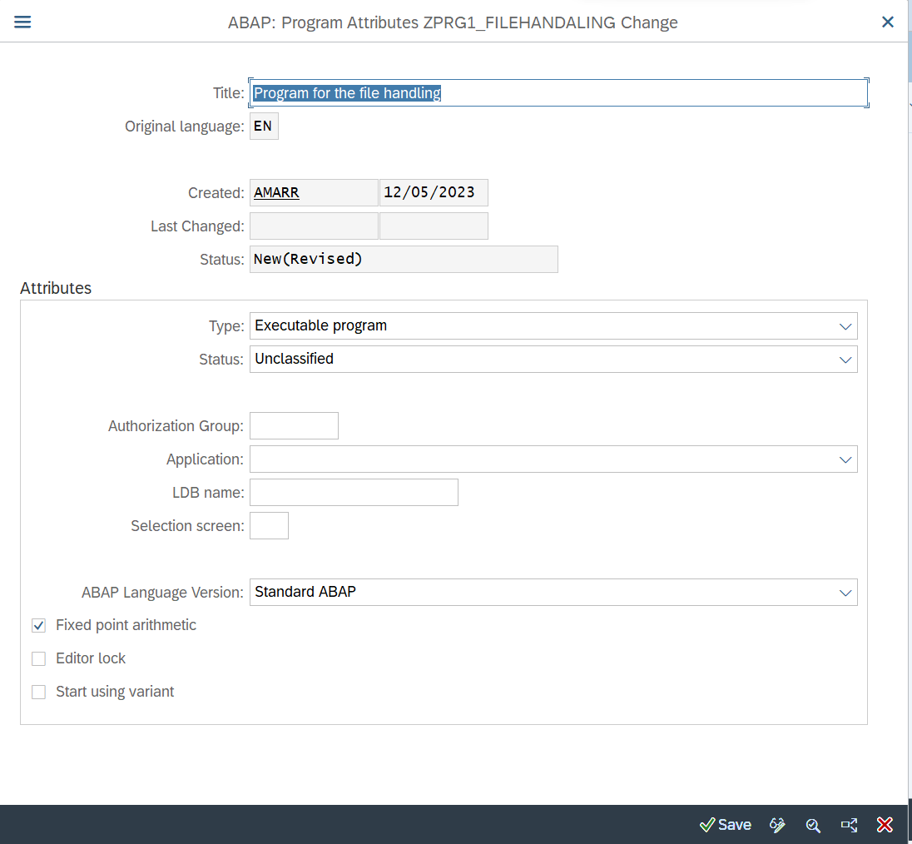

Figure 7 Create executable program.

#### Create user parameter.

To upload the file, we need to create selection screen.

We will use type localfile.

PARAMETERS: p_file TYPE localfile.

Localfile: - It is sap predefine data element it has a domain of character 128

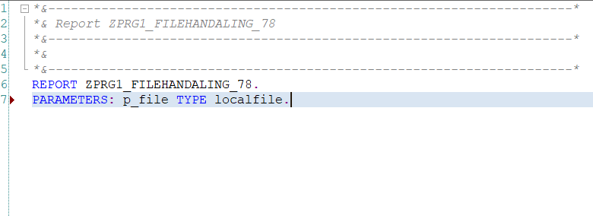

Figure 8 Parameters for the selection screen.

Give text element to the parameter.

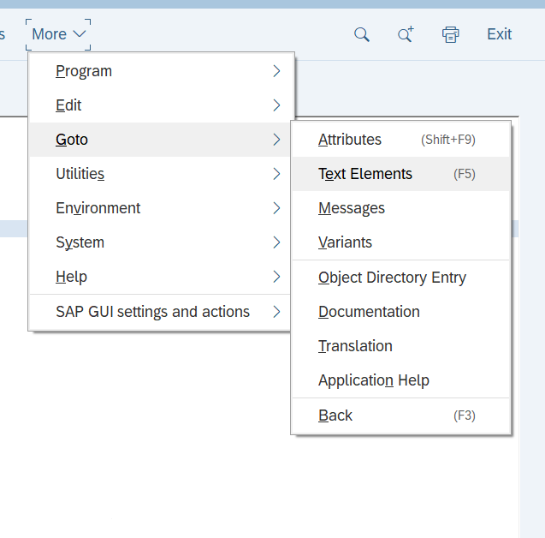

Figure 9 Give filed name to text element.

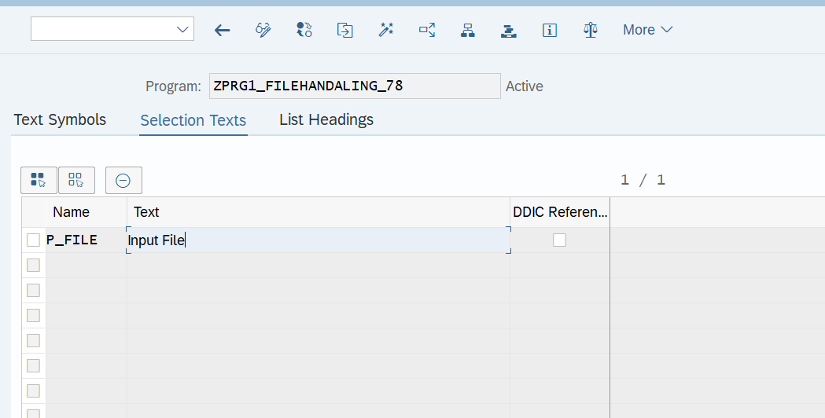

Figure 10 Giving the selection text.

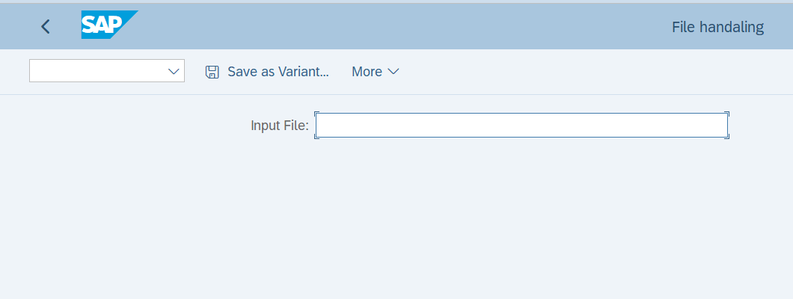

Figure 11 Input is ready.

#### Pass F4 button to redirect to application server.

Whenever user will click on the help button, we will show our presentation server and user will select the document.

Whenever we are doing some acting on the screen at that time at selection event is used.

F4 help = Value request.

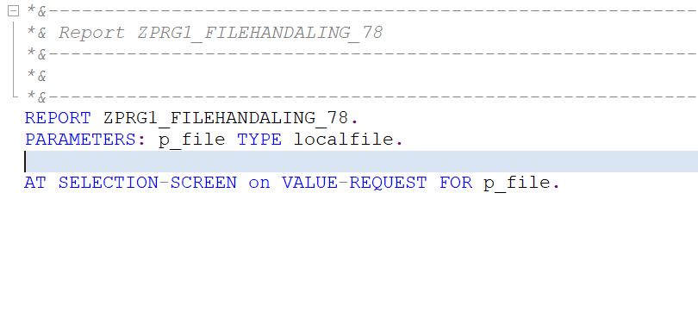

Figure 12 at selection screen for F4 help.

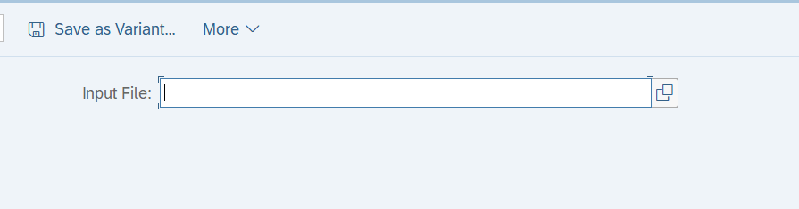

Figure 13 Now we can get F4 help.

#### Now whenever user click on F4 help we will take home to application server.

To achieve this in sap have provided a function module.

F4_FILENAME: - It will show you the desktop of the presentation server whenever we select the file it will return the path of the file

##### Navigate to Pattern.

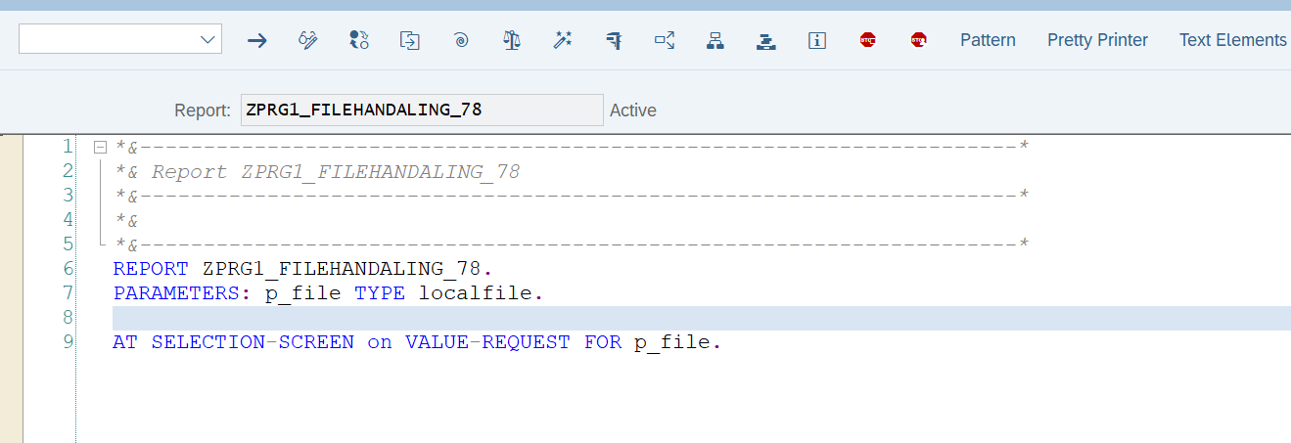

Figure 14 Navigate to pattern.

##### Pass the name of function.

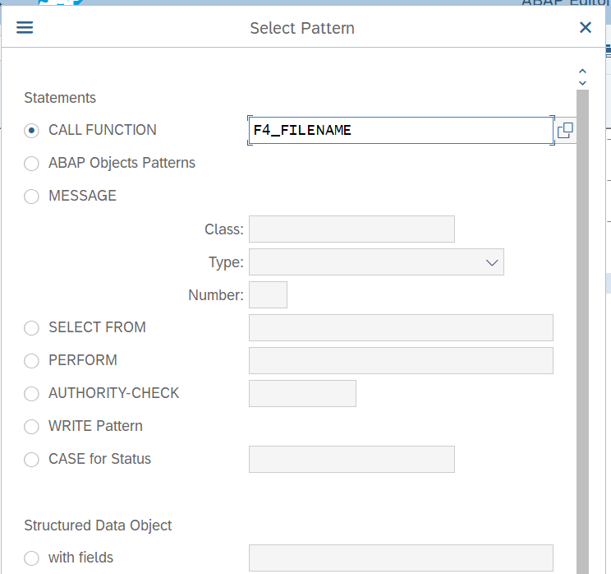

Figure 15 Pass the name of the function.

##### Use the function.

Uncomment the import export.

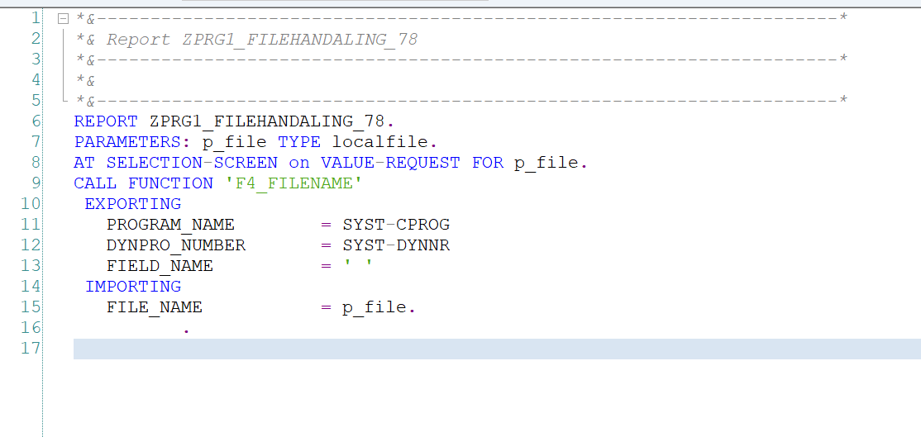

Figure 16 Uncomment the import and export.

In which parameter we will get the file name pass it to the FILE_NAME.

Now whenever we click on the F4 help on the selection screen we are going for the value request so the event get called now the function module will get called as it is the part of the selection screen, we will select the file we will get the full path of the file.

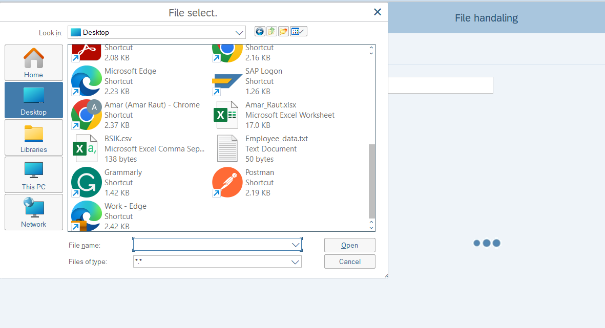

Figure 17 We are able to select the file.

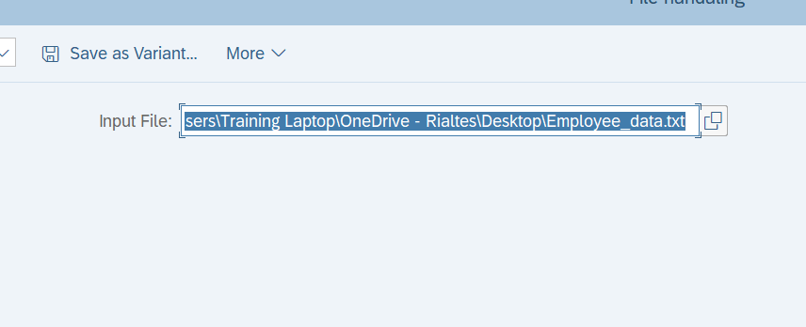

Figure 18 We get the full path of the file on the application layer.

#### Read the data from the file.

Whenever we click on the execute button, we want to read the data from the file that we have given path from the application server.

Whenever **we click on the execute button sap is calling start-of-selection event** so the start-of-selection we will use the function module GUI_UPLOAD to read the data.

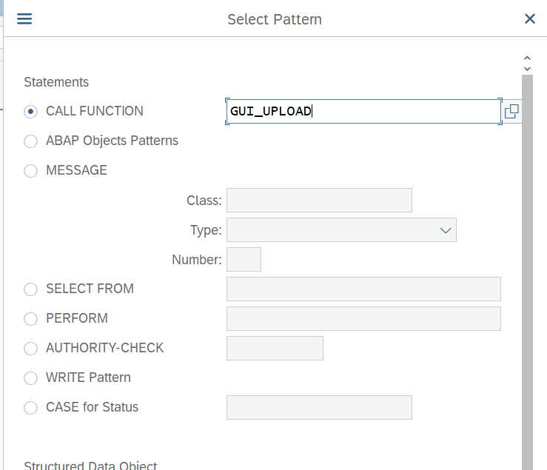

Figure 19 After start-of-selection import it from pattern.

This function module will read the data from the file.

Give the file name full path.

FILENAME = p_file.

HAS_FIELD_SEPARATOR = ‘X‘.

If we want to set it to True use X(Capital)

Tip: - Best practice uncomment the exceptions.

Now it will return the data in the internal table so we will create the internal table for the user id and name in this case.

##### Create a Structure.

Create a structure for the two fields.

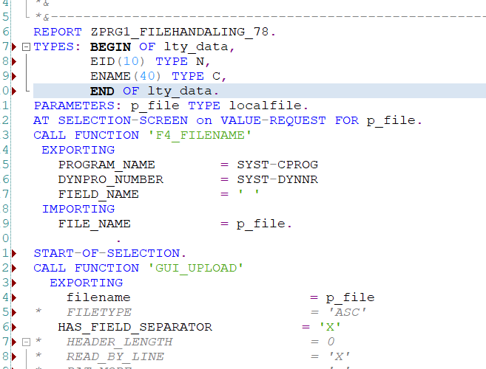

Figure 20 Structure for the two fields.

##### Create Internal table and work area.

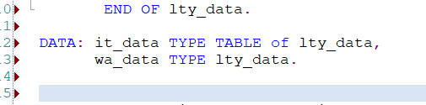

Figure 21 Declaring internal table and work area.

##### Pass the internal table name in data_tab.

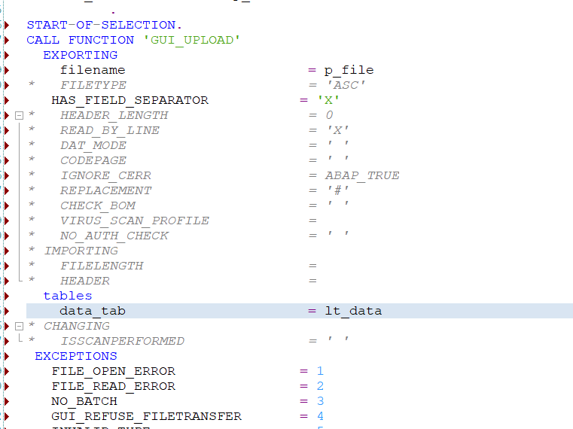

Figure 22 pass the internal table.

##### Solve the error.

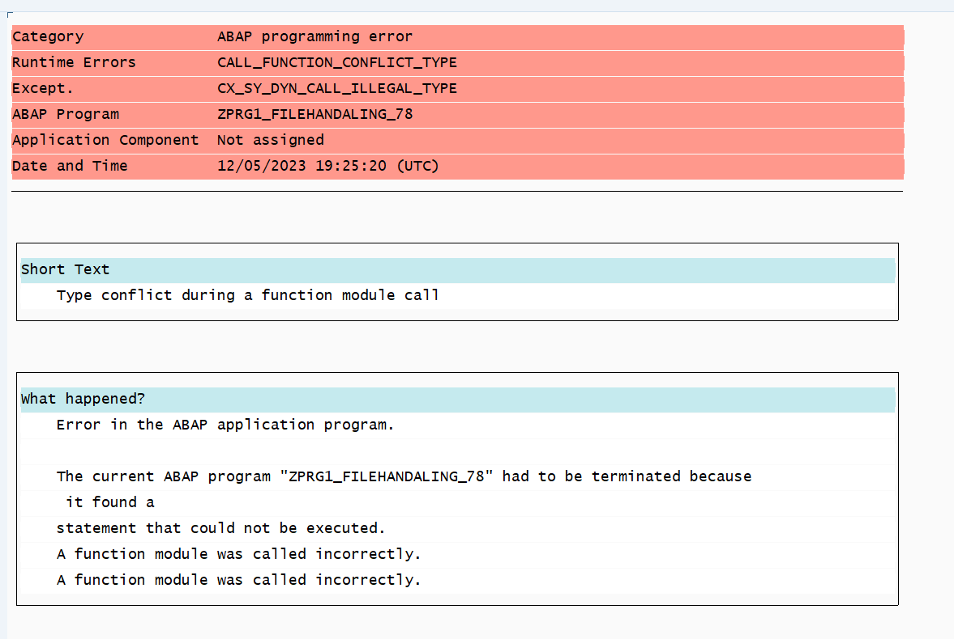

Figure 23 Runtime error.

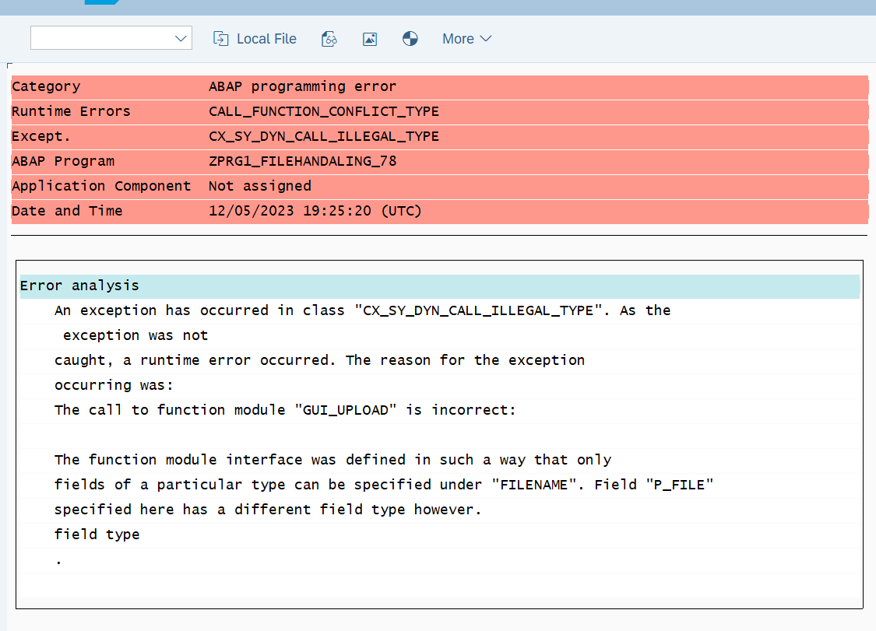

Figure 24 File name and p_file miss match.

We are getting a runtime error it is saying it that type conflict during the function module between filename and p_file

P_file is character 128 and filename is of string type we are passing character to string that’s why the miss match is.

Solution: - Typecasting

Declare the variable with string data type and convert the character to string data type.

Data: lv_file TYPE STRING.

Lv_file = p_file. “type casting

Now pass the type casted file name to FILENAME

FILENAME = lv_file.

Upload from excel: - <https://www.kodyaz.com/articles/abap-text_convert_xls_to_sap-upload-data-from-excel-file-to-internal-table.aspx>

## File Handling on Application Layer.

A file that is on our application layer which means on AL11.

* 1. OPEN DATASET: - Opens the specific file.
  2. CLOSE DATASET: - Close the specific file.
  3. DELETE DATASET: - Delete the specific file.
  4. READ DATASET: - Read a record from the file.
  5. TRANSFER: - Write a record into a file.